Biography of Richard Gransome

The great explorers of my time have discovered a new land thousands of miles to the west of Europe. Columbus “discovered” North America (someone would have run into that great land mass eventually). Amerigo gave it and its massive sister to the south their names. Mister Balboa laid eyes on the vast ocean to the west of the Americas. My friends from England searched in vane for a northern passage to the Far East and back to their home. Never finding a northwest passage. Even centuries before, the great Marco Polo brought back stories of the exotic orient all without traveling over seas. Now I need to make my mark on this world and do something that none of these “brave” men ever thought would be possible.

It has been thousands of years since anyone truly thought that our great Earth was flat. Learned men have known that the world is a sphere. Round like a billiard ball. Spinning round and round so that the sun and moon rise and fall in a timely manner. Balls roll and spin, which means that I too can follow a path around that ball. From one end to another without repeating my path.

The navigational schools that I have attended in Europe are spreading new ideas and introducing new technologies that will enable me to attempt a long ocean crossing. Voyagers no longer need to stay close to the shore to find the way from port to port. We can now use the stars, the horizon and the North Pole to help determine our location anywhere on the planet!

I was born by the sea and the sea flows in my veins. I have met very influential people during my time learning from the greatest scholars of Europe and the minds of my home country England. I am friends with noblemen, dukes, duchesses, even prince and princesses! If I can convince them of the necessity of traveling around the globe, and get them excited to bring fame and fortune to our country, then I will be able to afford such a long and dangerous journey.

I will leave England a virtually unknown explorer. Headed west into the setting sun. When I return, from the opposite direction, landing on English shores by heading West at all times, I will be more famous than old Chris Columbus himself! School children will know my name and learn of my greatest for centuries to come. The world is my oyster!

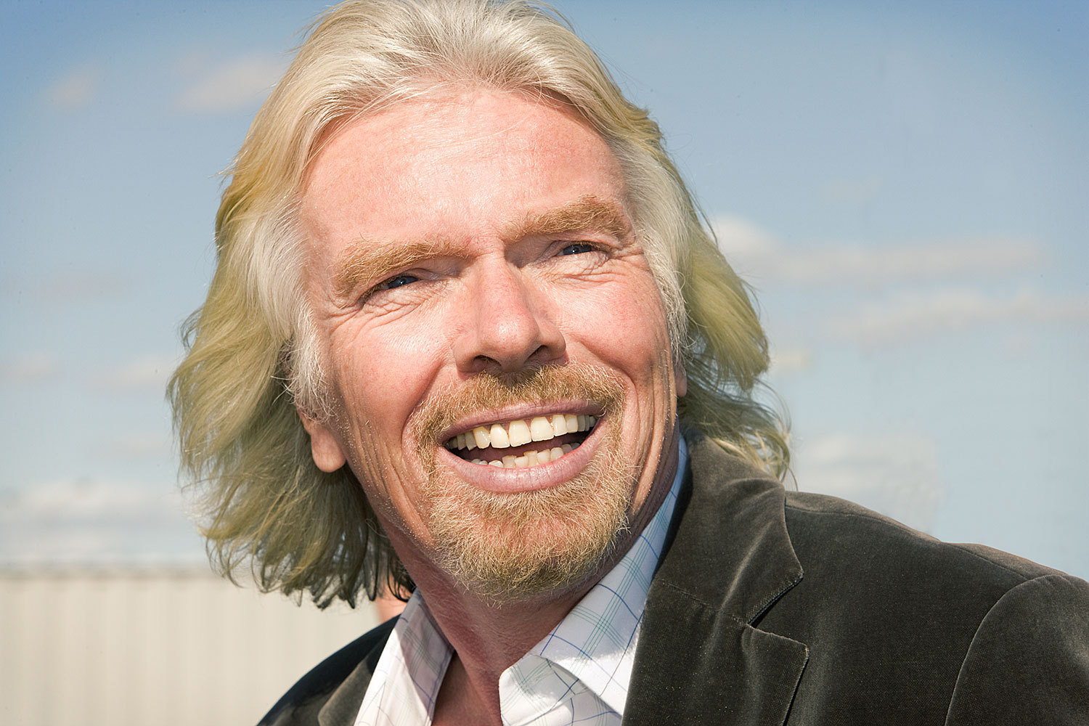

Biography of Enrique de la Vega

I was born in the town of Medellin in Extremadura, Spain. My father is a captain in the infantry where he gained a strong reputation. My mother is a descendant of lessor nobility, but we still struggle financially. I was frequently sick as a child and was much weaker than the other boys.

In my early teens my parents sent me off to study Latin with my uncle, and after two years I returned home. My parents were irked by my return because they had visions of me becoming a lawyer. My schooling wasn’t all for nothing, however, because it gave me the skills to become a notary. This position afforded me with the opportunity to meet some very important and influential people in Spain, including the king and queen who could help me finance the cost of a great expedition.

To my parents joy, I became familiar with the legal codes and laws of Spain. I really enjoyed the laws and codes about Spain’s rights to expand its territory and spread its culture throughout the world. I think that Spain should take advantage of these laws to expand and spread their influence. I wonder if the new lands from by Christopher Columbus will give us an opportunity to become a wealthier, more powerful nation?

News of Christopher Columbus’ discovery of the New World has touched something deep inside me. I feel a purpose building inside me and I see a path for my next steps in life. There is a whole other world out on the other side of the Atlantic just waiting to be discovered, explored, conquered, exploited, and claimed for the glory of Spain!

The navigational schools that are popping up throughout Europe are spreading new ideas and introducing new technologies that will enable me to attempt a long ocean crossing. Voyagers no longer need to stay close to the shore to find the way from port to port. We can now use the stars, the horizon and the North Pole to help determine our location anywhere on the planet!

This is an exciting time in the world. Bold men with money and support can take advantage of the knowledge and technology to explore the newly found lands to the southwest. Fortune, fame and the expansion of our nation are all possible.

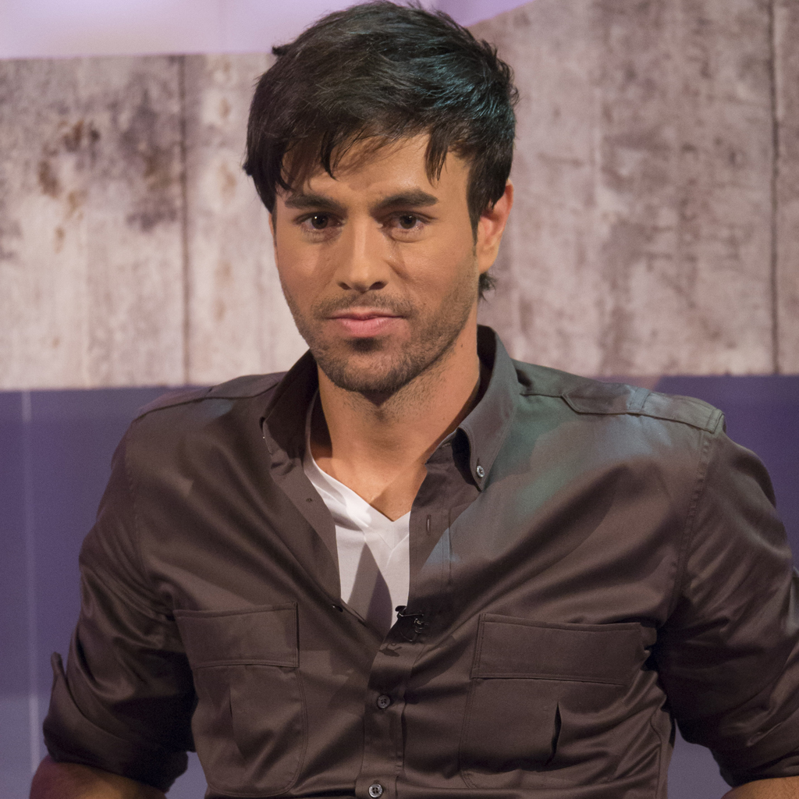

Biography of Henry Charles Albert

Many writers have pondered the question of the existence of a Northwest Passage from northern Europe to the lands of Asia. Ancient and modern men of knowledge have taken ink to paper and pondered the route around the roof of our world.

The seas, we know, swirl in great circles and flow with strong currents of fast moving water. Even the northern seas that flow past Scotland, Norway and Sweden have strong currents and a circular motion.

Finally, we have even seen men, alien to our land, arrive via the sea from the Northwest, seemingly out of nowhere. Upon arrival these men came from the distance land of India. To make that great voyage without traveling overland they must know of passage over the North Pole to the English Isles.

I am a loyal English citizen and wish to bring glory to my great country. The British navy is lagging behind Spain and Portugal in the discovery of new lands, passages and routes to the west. It is high time for a monumental discover by a servant of the throne to shake the world and change the path of trade and navigation.

The navigational schools that are popping up throughout Europe are spreading new ideas and introducing new technologies that will enable me to attempt a long ocean crossing. Voyagers no longer need to stay close to the shore to find the way from port to port. We can now use the stars, the horizon and the North Pole to help determine our location anywhere on the planet!

The seas and land to the north will not be friendly, I know. I must prepare myself, my crew and my vessel for the roughest of seas, the coldest winds, and the least forgiving of climates. This will not be a leisurely voyage across the ocean at the equator where men work bare chested and sleep under the stars. Timing this voyage will be equally important as the sun can hang in the sky for days on end in the summer months without ever setting. While in the winter we may not feel its warmth or see its light for a month. I have also heard tales of massive white bears that can snatch a man off of the ice and swim in the open ocean. Men tell tales of seals with huge tusks, and islands of ice that topple over without warning. I Preparation will be of utmost importance on this voyage.

To find a trade route to the east and bring glory back to my beloved England would be my greatest achievement. My time in the navy has giving me the skills I need, the King will provide me with the funds I require, all I need to bring is the bravery and guts to find something that no one has ever discovered!

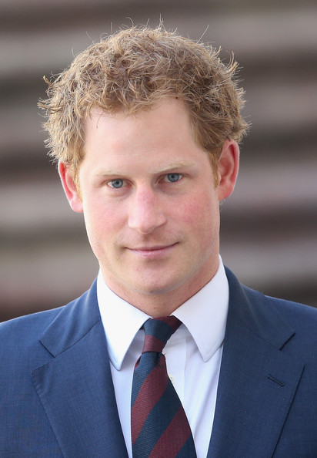
Biography of Phillip Roberts

The Portuguese, whom I am one, and the Spanish, whom I am not, have always been at each other’s throats. We are next-door neighbors on the Iberian Peninsula. Neighbors either become best friends, or mortal enemies. We are the later. The Treaty of Tordesillas may keep us Portuguese from traveling too far west in the Atlantic, but that doesn’t mean we are stuck. The compass has more points than that and I mean to find a way to the treasures of India and the Orient!

I was born by the sea and have the sea in my blood. I was trained in mathematics and navigational by some of the greatest minds Portugal has to offer. In my teens I joined the navy and became skilled at the art of sailing. I am most at home on the sea and feel restless when I am forced to stay on land for too long.

The navigational schools that I attended introduced me to new ideas and technologies that will enable me to attempt a long ocean crossing. Voyagers no longer need to stay close to the shore to find the way from port to port. We can now use the stars, the horizon and the North Pole to help determine our location anywhere on the planet! However, it is always safer to stay close to shore when traveling into the unknown. Maybe I should stay near a large land mass as I open trade routes to India and the Orient.

I, like my father, am a member of the Order of the Santiago, as is our great leader King John II. Members of this order will help each other in any way possible. Money, men, and supplies are all mine with little more than a request to my powerful friends.

News of the successful adventures of my Portuguese brothers down the coast of Africa, and to Egypt via the Mediterranean Sea, have me thinking: is there another way to exploit the riches of India and ports in the east; to unite our gold with their spices and silks? Overland routes take months. The sea is faster, but the way is unknown.

The riches of India and the vast countries of the Orient are famous. Silk, spices, gold, silver, and jewels of every description are available to anyone bold enough to venture there. The biggest obstacles are that the trip costs so much in money and time. Is there a faster way to go? Does the massive land of Africa ever end? Is there a way to reach India and the Orient quickly and have the ability to return with large quantities of cargo?

