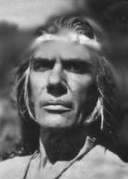
I am Chief Chowig. I am Chief of my people. We live by the ocean. Our ocean is filled with fish, squid, crabs, and many other foods we eat everyday. We grow corn, beans, and squash. They grow very well together. My people are peaceful. We are close to our families and believe the earth gives us everything we need. We appreciate their gifts of food, water, beauty, clothing and shelter. We live in harmony with the land. We value our freedom to go where we want and do as we please. We believe in respect for our land, our people and the earth, so we do not fear our people will do bad things. However, we have heard from far away places that white men are coming to take over our homes, tear our families apart, and tell us what we should believe. I tell my people everything will be fine, but they have heard news of other places in the Central Valley where the Yurok live . . . white men have come and have ripped families apart, forced them to eat their food, and put them in a place where they have no freedom to leave. They work hard daily doing meaningless work like making bricks day after day, night after night. They have heard the Yurok people have died from sickness they have never seen before. And those who try to escape are beaten. I try to calm my people, but they grow worried, and sad every day. As Chief Chowig, I have made a promise to protect my people and not fear the future of change. We know change will come, we are not afraid, but we cannot be expected to give up our culture, our food, our beliefs and our way of life. My people everything to me.
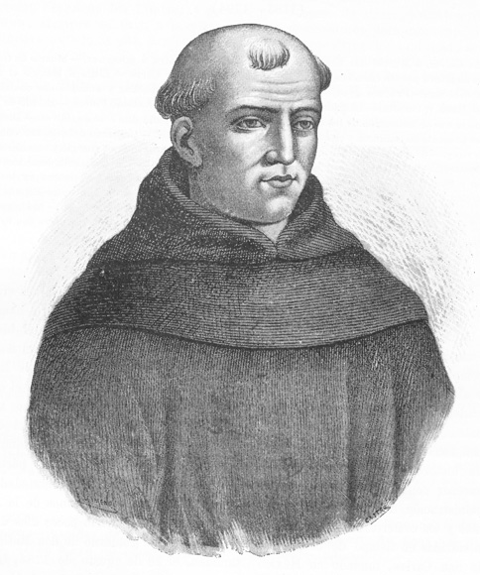
My name is Junipero Serra. I am a Franciscan priest, sent from my native country, Spain, to teach the local savages, also known as Indians the Spanish religion and ways of life. My country is interested in taking this land because of its amazing resources. This land has the ocean, the forest, the desert, and the mountains . . . all regions filled with valued resources.

However, my personal interests lie saving these people. God has brought me to this place to teach these unruly people with strange clothes and ways of life to better them. God has sent me to help them. He has sent me to build a place for these people and help them from their wild ways. I bring my few missionaries in peace, to only save these people.

I have heard stories that the Natives here think we are only here to hurt them. I have heard those who speak both languages say we bring disease and make them sick. We make them work hard everyday, but we are only here to help. The hard work the Natives do on our land, will bring them closer to God. They should appreciate the food, shelter and work God has so graciously provided for them.

God says we must work hard to reach the paradise he prepares us for and I am helping them to reach this place of paradise. They will live better lives. We are here to help them live for God and seek peace. I do not understand their language but I know they need help. I have devoted my life to this cause. They’re devotion to God is what is most important to me. I wish I can convince them of this.

Name:
Research Categories

What is your name? (you can come back to this after you do more research)
Chief Chowig

Describe some things that Native Americans believe in.

Native Americans believe in the land. They respect it and use it for everything. They are not wasteful. Native Americans also believe that natural disasters etc. are caused by different gods. They pass legends along.

How did Native Americans get their food?

Native Americans get all of their food from the land. They fish in rivers, hunt game and collect plants and seeds.

What were Native Americans’ homes and clothing like?

________________________________________________________________________________________________________________________________________________

What were some challenges that the Native Americans faced?
________________________________________________________________________________________________________________________________________________________________________________________________

Name:
Research Categories

What is your name? (you can come back to this after you do more research)
________________________

Describe some things that your missionaries believe in.

________________________________________________________________________________________________________________________________________________________________________________________________

How did the missionaries get their food?

________________________________________________________________________________________________________________________________________________

What were missionaries homes and clothing like?

________________________________________________________________________________________________________________________________________________

Why were the Spanish missionaries interested in living in California?
________________________________________________________________________________________________________________________________________________________________________________________________

