Create Your Own Dichotomous Key

In this activity, you will be creating a dichotomous key. Dichotomous keys are tools used by scientists to identify unknown organisms. To create your key, follow the steps outlined below. All completed projects will be worth 15 points and will be graded according to the attached rubric. Good Luck, Have Fun, and Be Creative!
- Observe the collection of shoes on the table in the middle of the room.
- Select 10 different species (shoes) from this group. At the top of your key, make a list of the shoes you have selected, identify them by the owner’s name. These will be included in your key.
- Decide upon a way to divide the shoes into two groups. Think of identifying characteristics such as shape, size, material, color, texture, etc. These characteristics must be observations. One characteristic must be defined and used to decide how items are separated. The groups created must be opposites of each other. For example: a group of big cats could be divided into those with long tails and those without.
- Record what factor was used to make the division and note which members of the original group belonged to each resulting group.
- After two groups (A and B) have been created, divide the first group (A) into two more groups based again on one criterion (C and D).
- Do the same with Group B. For example, if group A were the short tailed cats, group C might be short tailed cats with a plain colored coat. Group D would then be short tailed cats with a patterned coat.
- Continue to divide the groups until each item is by itself. Keep careful records of the groups that were created and the dividing criteria.
- Looking at your records and the divisions you made, create a dichotomous key that would lead someone else to make the same distinctions you did. Begin your key by recalling the first factor you used to divide into two groups. Again using the big cat example: The first group was created depending on tail length. So, the first question in the key should be: Does the cat have a short tail? If yes, go to step 2. If no, go to step ??? (You may need to wait until you have worked through several steps of the key to assign the second destination.)
- You can use the attached paper as a framework to fill in your key or you can type or write your own.
- When your dichotomous key is complete, ask someone else to use it to classify and identify the items. Does your key lead others to the same identifications you made? If not, you may need to make some changes.

Helpful Hints:

- While you are constructing your key, you must be as specific as possible so that the user does not become confused. If the two choices are not precise, a user can easily choose the wrong one, and may get the wrong classification or have to start over.

- It might help to save the numbering of the steps for the end of the activity.

- After we have rotated through the class testing each others’ keys, use the Post-it note hints to improve your key. Talk to the user if you don’t understand their confusion.

- All keys should have one fewer steps than items. So your key should have 9 steps with two choices for each one.

Dichotomous Key for Class Shoes Name:
List of classmates’ shoes classified:

Step 1 - | If YES, | Go to
 | If NO, | Go to
Step 2 | If YES,
 | If NO,
Step 3 | If YES,
 | If NO,
Step 4 | If YES,
 | If NO,
Step 5 | If YES,
 | If NO,
Step 6 | If YES,
 | If NO,
Step 7 | If YES,
 | If NO,
Step 8 | If YES,
 | If NO,
Step 9 | If YES,
 | If NO,

Name:
Grading Rubric: Your project will be graded according to the following rubric:
______ 5 pts. The Dichotomous Key followed the proper structure (identifying characteristics were used to create steps of paired opposites).

______ 5 pts. The Dichotomous Key was accurately worded. Classmates successfully used it to identify all 10 items.

______ 5 pts. The Dichotomous Key included proper spelling, punctuation and grammar. All work is neat, legible, and easy to follow.

______/15 Total points

Comments:

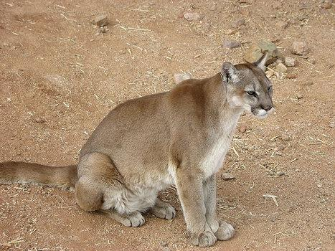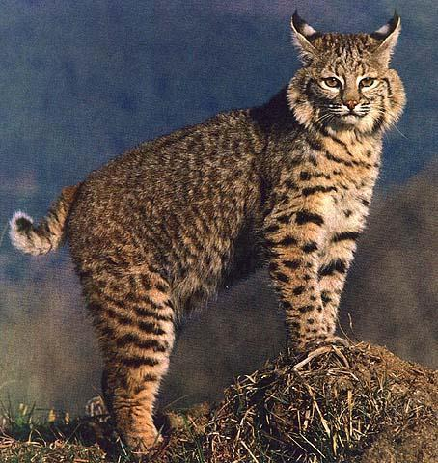
A B

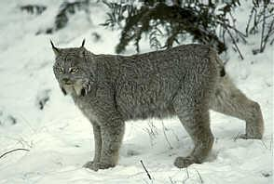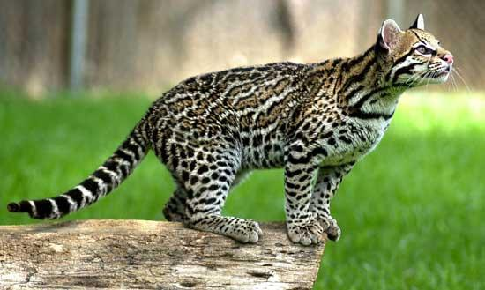
C D

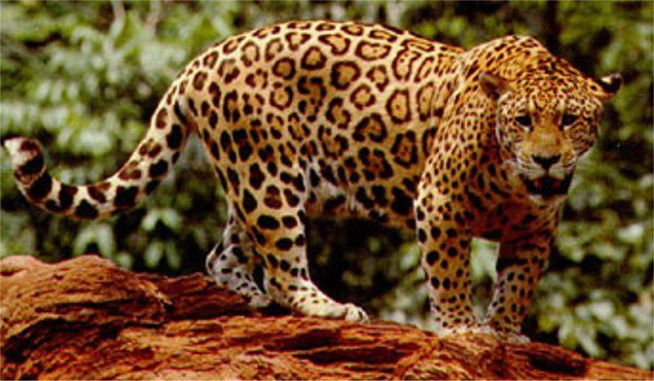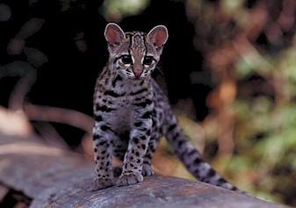
E F

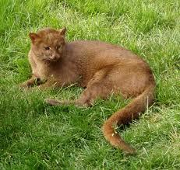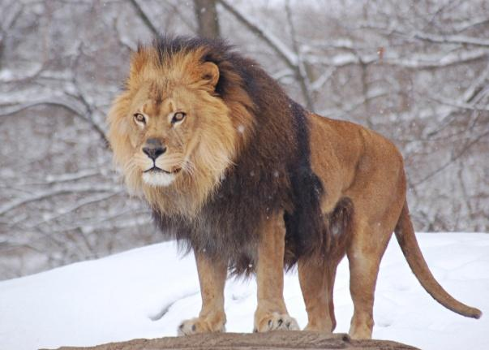
G H

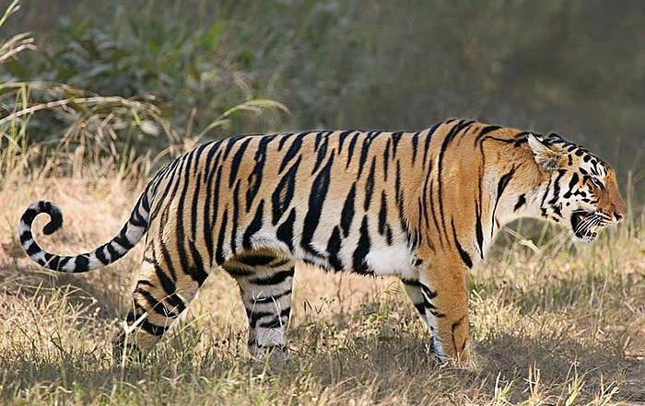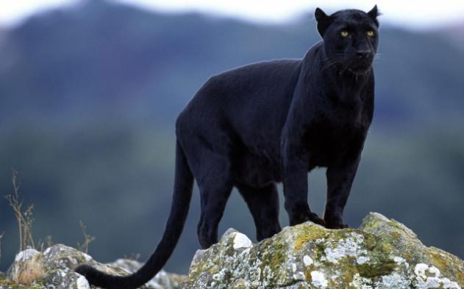
I J

Key to Wild Cats Name: ________________________
Period: ____________

1. Does the cat have a short tail?……………………………YES…………………….go to Step2
……………………………………NO………………….go to Step 3

2. Does the cat have long black-tipped ear tufts?……YES…….it is a lynx, Felis lynx
……………NO…………it is a bobcat, Felis rufus

3. Does the cat have a plainly colored body?………………YES………………..go to Step 4
…………………NO………………….go to Step 7

4. Does the cat have a distinct mane around
its neck (males only)? ……………………YES…………………..it is a lion, Panthera leo
………………NO…………..go to Step 5

5. Is the cat mostly tan to brown in color?…………YES……………go to Step 6
……………NO……….it is a black leopard, Panther pardus

6. Is the cat tan above with white to buff below?……YES…….it is a mtn. lion, Felis concolor
…………NO………….it is a jaguarondi, Felis yagouarundi

7. Does cat have noticeable black stripes?…………YES…….it is a Bengal tiger, Panthera tigris
………NO……go to Step 8

8. Is the cat clearly larger than a house cat?…………YES………..go to Step 9
……NO……..it is a margay, Felis wiedii

9. The cat has black-bordered brown spots?…………YES…………it is an ocelot, Felis pardalis
……………NO……………………..it is a jaguar, Panathera onca

Answer Key

- Mountain lion, Felis concolor

- Bobcat, Felis rufus

- Lynx, Felis lynx

- Ocelot, Felis pardalis

- Jaguar, Panathera onca

- Margay, Felis wiedii

- Jaguarondi, Felis yagouarundi

- Lion, Panthera leo

- Bengal tiger, Panthera tigris

- Black leopard, Panther pardus

